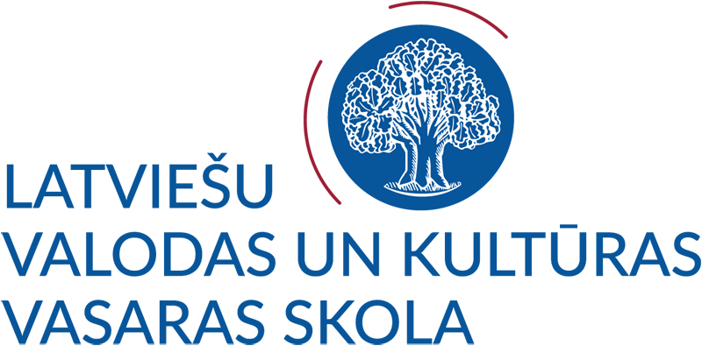
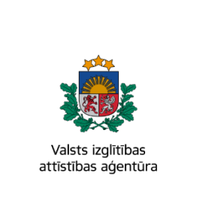


APPLICATION FORM
FOR SUMMER SCHOOL OF LANGUAGE AND CULTURE 2023
July 27 – August 9, 2023
This form should be typed.
Please submit the application form by e-mail (signed and scanned) no later than June 1, 2023.
Application deadline for the Latvian state scholarship applicants is April 1, 2023.

Late applications will be considered if there are any spare places left.
Complete the form carefully and together with the required enclosures send by e–mail: sagkursi@lu.lv.

- Personal data 2. Mailing address
First name(-s):  ………………………………………….………..  Last name/surname:  ……………………………………….…..………  Gender: □ Female □ Male  Date of birth (Day/Month/Year):  ……..………/…………….…/…………...….…..  Personal number: …………………………………………  (if a citizen of the Republic of Latvia)  Citizenship:………………………...…………… | House and Street:  ………………………….………….…………..………...…  City:……………………  Postal/ZIP code:………………… Country:………………..…………………………………..  E–mail: ……………………………………………………  Telephone: + ……………………………….………………
- Occupation
Educational background (the name of the institution):
□ University …………………………………………
□ College ………………………………………….
□ Other……….…………………………...…..………
Profession: ……………………………….…… Present occupation:……………..…………...………………
- Applicant’s home institution
Name of institution:…………………………….……… Faculty/Department:……………..……………………
Contact person at home institution:…………….............. E–mail of contact person:.……….……………………
- Applicant’s Latvian language skills
A: entry level  □ No prerequisites required | B: intermediate level | C: advanced level
□ Beginner (A1) | □ Pre-Intermediate (B1) | □ Advanced (C1)
□ Elementary (A2) | □ Intermediate (B2) | □ Expert (C2)
- In case you have already studied Latvian, please indicate
Institution:……………………….……. Duration of studies:……..……………. Level of studies:……………….
The textbook(s), material or website used:…………………………........................................................................
Please describe your Latvian language skills (e.g., conversational, fluent):
………………….....................................................................................................................................................
- Language competence (underline)
Mother tongue:………………………
Other languages: English (basic, good, excellent) German (basic, good, excellent)
French (basic, good, excellent) Other …………………. (basic, good, excellent)
8. Scholarships
□ Latvian state scholarships (The State Education Development Agency)
□ Not necessary
9. Your hobbies and interests?

11. Documents for submission
Please, ensure that the application is complete and that it includes the following items:
□ application form
□ Curriculum Vitae (only for those who wish to apply for a Latvian state scholarship)
□ letter of motivation (a cover letter) (only for those who wish to apply for a Latvian state scholarship)
□ copy of passport/ID card (only for those who wish to apply for a Latvian state scholarship)
□ statement / confirmation of the university/ college/school (only those who wish to apply for a Latvian state scholarship)
□ payment statement (registration fee)
□ payment statement (participation fee)
- The course fees (tick an option convenient for you)
□ international transfer by 01.04.2023 (registration fee–referring to students who wish to apply for the Latvian state scholarship)
□ international transfer by 01.06.2023 (registration fee)
□ international transfer by 01.06.2023 (participation fee)

- Accommodation:
A room in a student hostel:
□ Double room (shared with another person)
□ Single room
□ Accommodation not necessary

- Contact person (in a case of emergency):
Name, surname………………….……………… Relationship to you…… ………………..………..………..…
House and Street…………………………..…… Post code…………… Country……………………………….
City……………… e–mail ………………………..…………….…… Telephone: + ……….………….………
I confirm that information I have provided in this application and in any attached document is true and correct.
Please note that the University of Latvia is not responsible for the travel and medical costs bared by the participant. We recommend purchasing an insuarance policy.
Should you decide to cancel your participation, you have to inform us at sagkursi@lu.lv by 01.06.2023.
If you withdraw or decline participation in summer school until 15.06.2023, we withhold 10 % from your
paid participation fee and if you withdraw or decline participation until 01.07.2023, we withhold 50% from your paid participation fee. Please remember that registration fee is non-refundable.
The UL will process applicants’ personal data only for UL study process and academic and administrative research purposes, scientific and statistical studies, as well as in other cases specified by the study agreement or the laws of the Republic of Latvia.
If you have questions about the protection of personal data, please contact the University of Latvia Personal Data Protection Specialists by writing to data.specialisti@lu.lv.
The participant is released from liability for partial or total non-compliance with the participation rules of the “Summer School of Latvian Language and Culture 2023” if it is due to insurmountable circumstances, including the spread of COVID-19 virus in the European Union and the world (new laws and regulations issued by the state and the European Union).

Date ……./……/2023 Signature……………………………...

